**AWS Task-1**

Create a windows Vm machine in AWS

Used t3.medium instance type, by using t3.micro, RDP is taking more time to start so used t3.medium

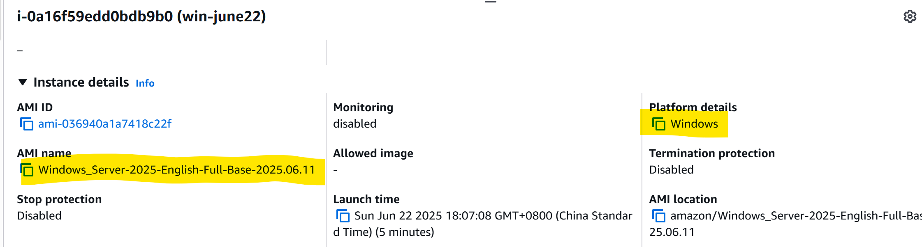

Donwload RDP and get the password by uploading the pem file

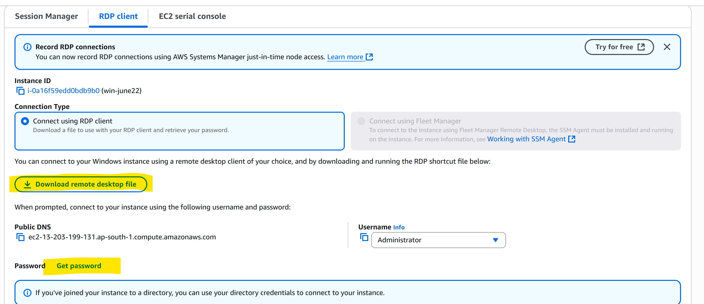

Open the RDP file in your local machine and enter the password

connect with RDP open CMD in windows share the about system info.

